Supply List for Layered Raw-Edged Appliqué #3 –
Holly – Snowflake – Ginkgo
By Ilene Bartos
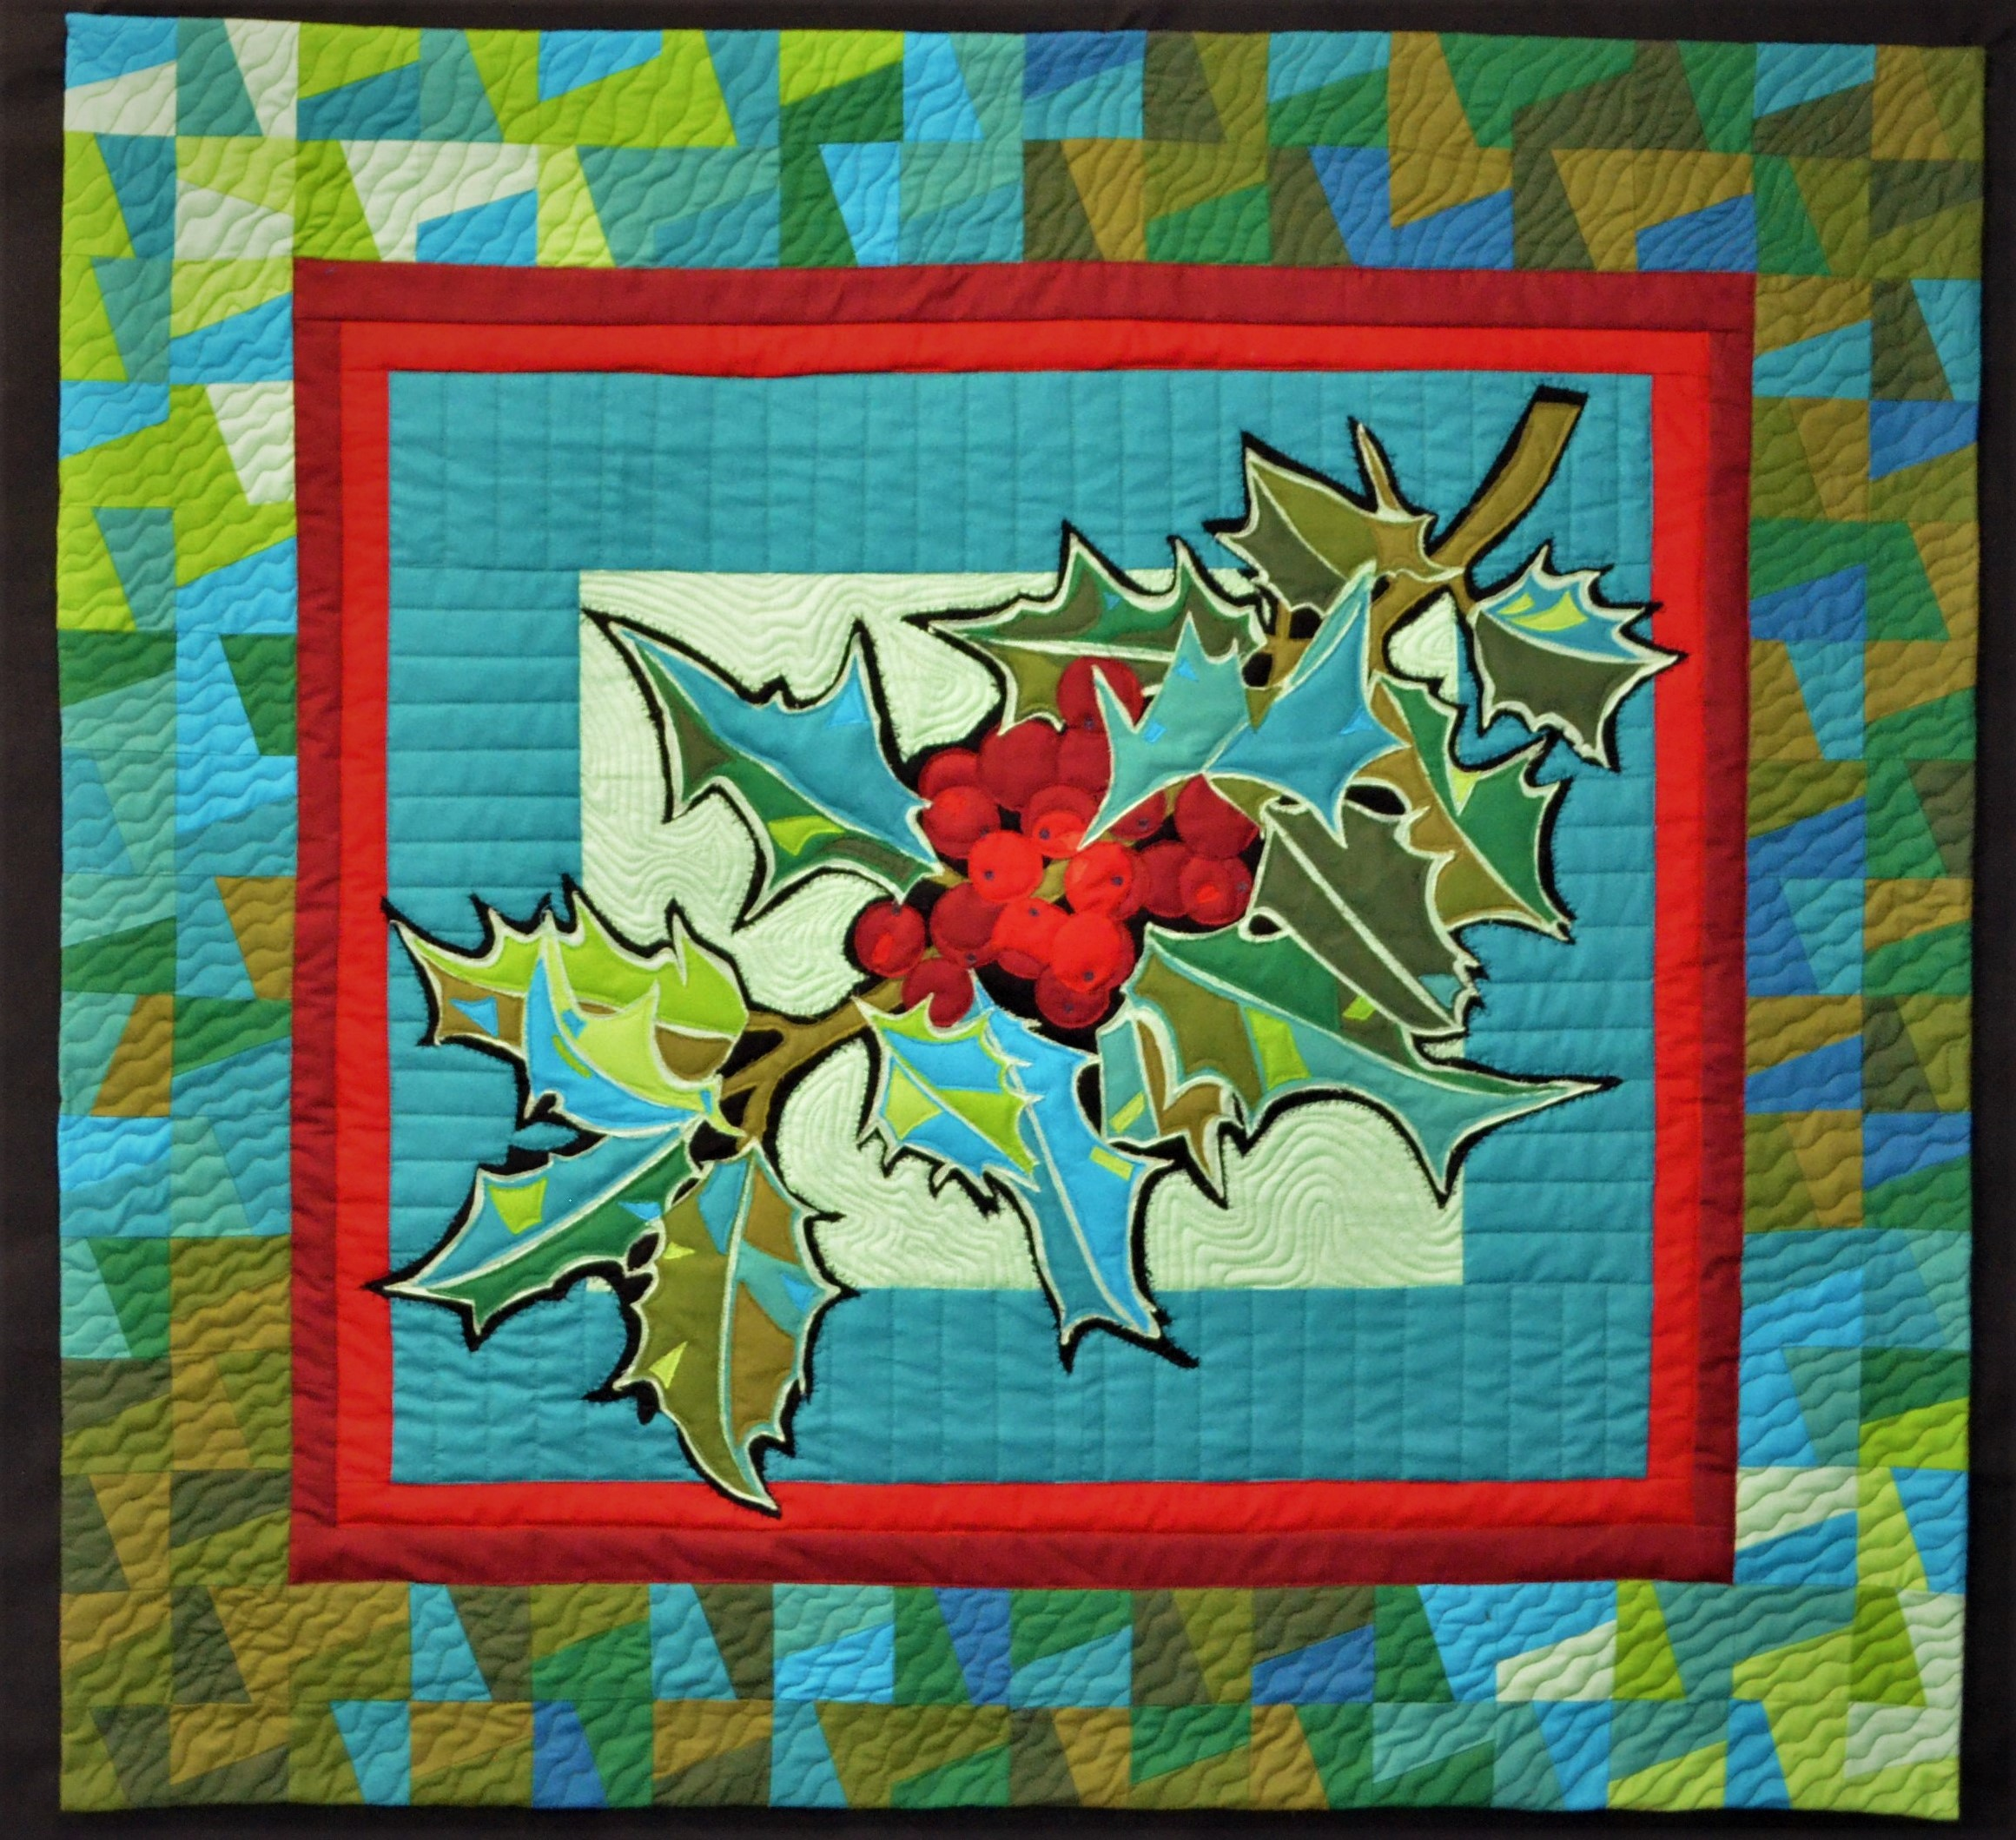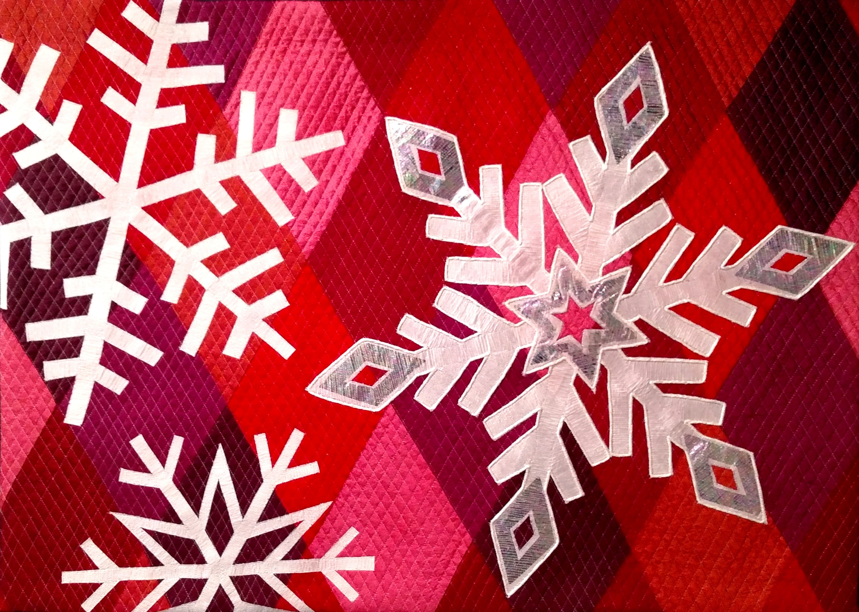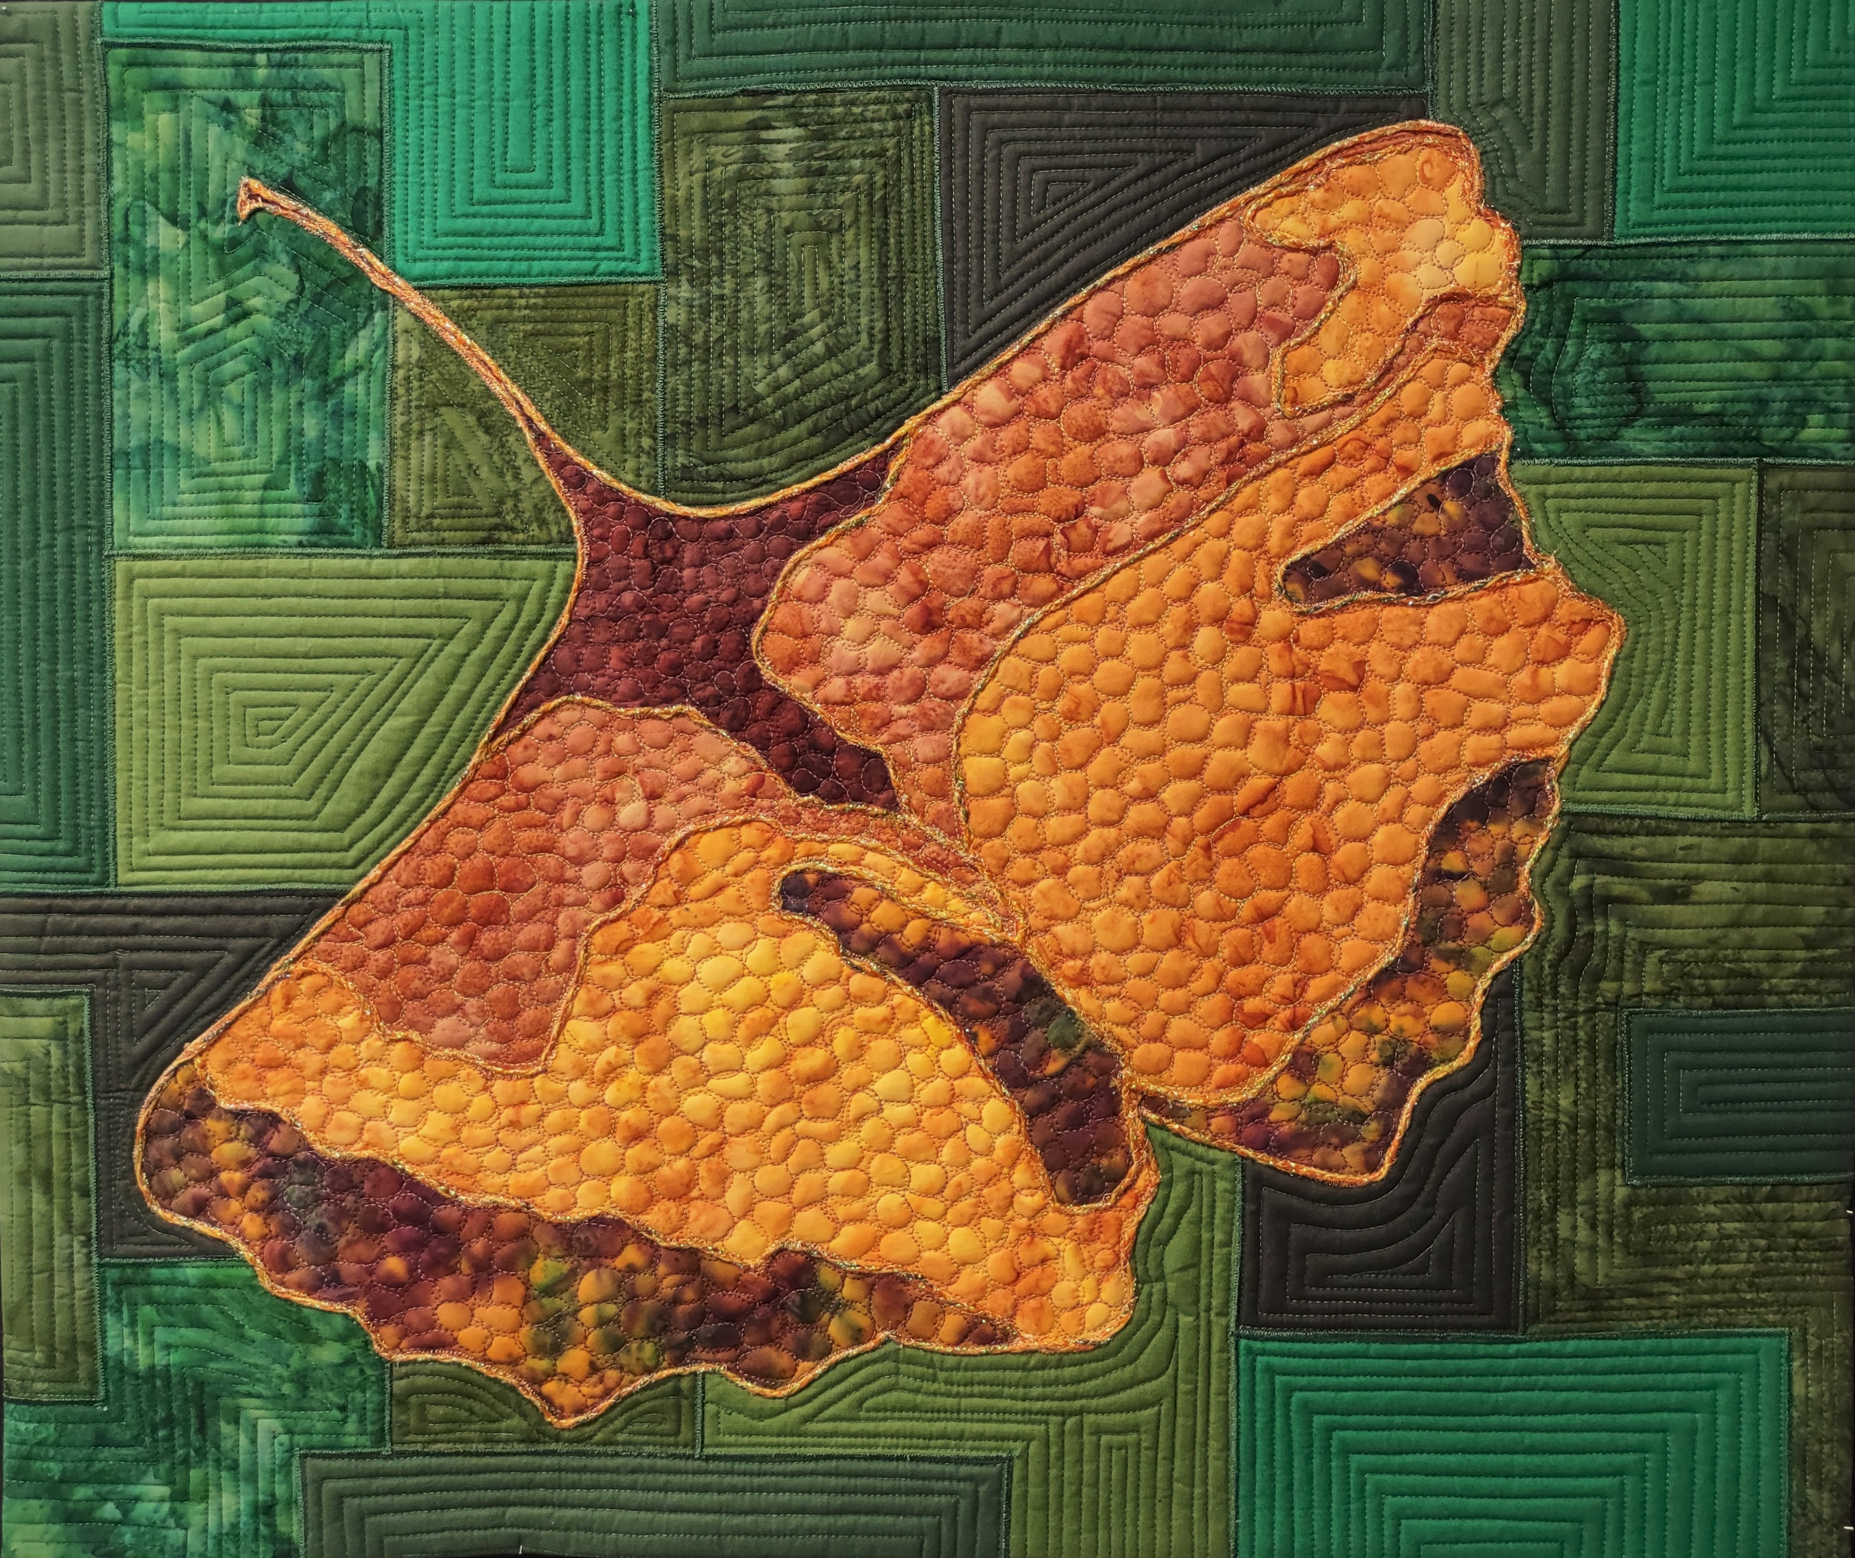
Holly – 36” x 39” Snowflake – 28”x 93” Ginkgo – 26”x 32”

- Sewing machine in good working order with normal attachments, including a quilting foot, open toe foot, quarter inch foot, and cording/piping foot
- Extension cord and/or power strip (unless these are provided for us)
- Iron and ironing boards (unless these are provided for us)
- Rotary cutter, mat, rulers
- Scissors, both paper and fabric
- Highlighters
- Thread – Black and colors to match fabrics
- Pattern - Pick any of the 3 patterns. I will bring these with me (or you can buy on-line at www.ilenebartos.com shipping will apply but no sales taxes) Holly Pattern-20.00; Snowflake Pattern-26.00; Ginkgo Pattern–20.00
- Kits that INCLUDE the pattern will also be available at class. Holly Kit – 96.50; Snowflake Kit (blues or reds) – 61.00; Ginkgo Kit – 77.00
- You are also free to bring your own fabrics as listed below.
- 3-4 yards of paper backed fusible - my favorite is Soft Fuse or Flexi-Fuse
- Parchment Paper (this is in place of the stabilizer listed on the pattern)
- Marking tools – pencil and permanent marker (no ink)
- Optional: Temporary Spray Adhesive such as Sulky KK2000
- Light Box (optional)
- Large baggies for organizing fabrics
- Large Wool Pressing Mat - Optional
- 1 7/8 yards for backing and facing
- Batting

Fabrics if you are bringing your own:
- Holly: 2/3 yard black; 10 Greens, light to dark; 1-yard Lightest Green 1; 1/3-yard of Green 2-5; 5/8-yard Green 6; 3/8-yard Green 7; ½-yard Green 8; 3/8-yard of Green 9; 3/8-yard Darkest Green #10.
- Snowflake: 8 cuts ¼-yard of reds/blues for background (do not use fat quarters). 7/8-yard white for flakes. White cording/yarns; Foil.
- Ginkgo: Various cuts of golds; 8 fat-8th cuts of variety of greens for background. Stabilizer. Yarns, beads.

