Supply List for Aboriginal Series Class
Moonlight – Neighborhood – Cobblestones - Hills
By Ilene Bartos
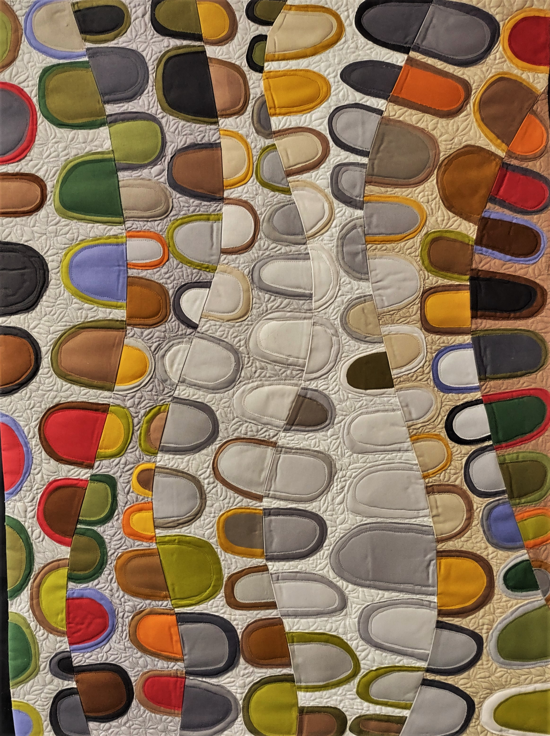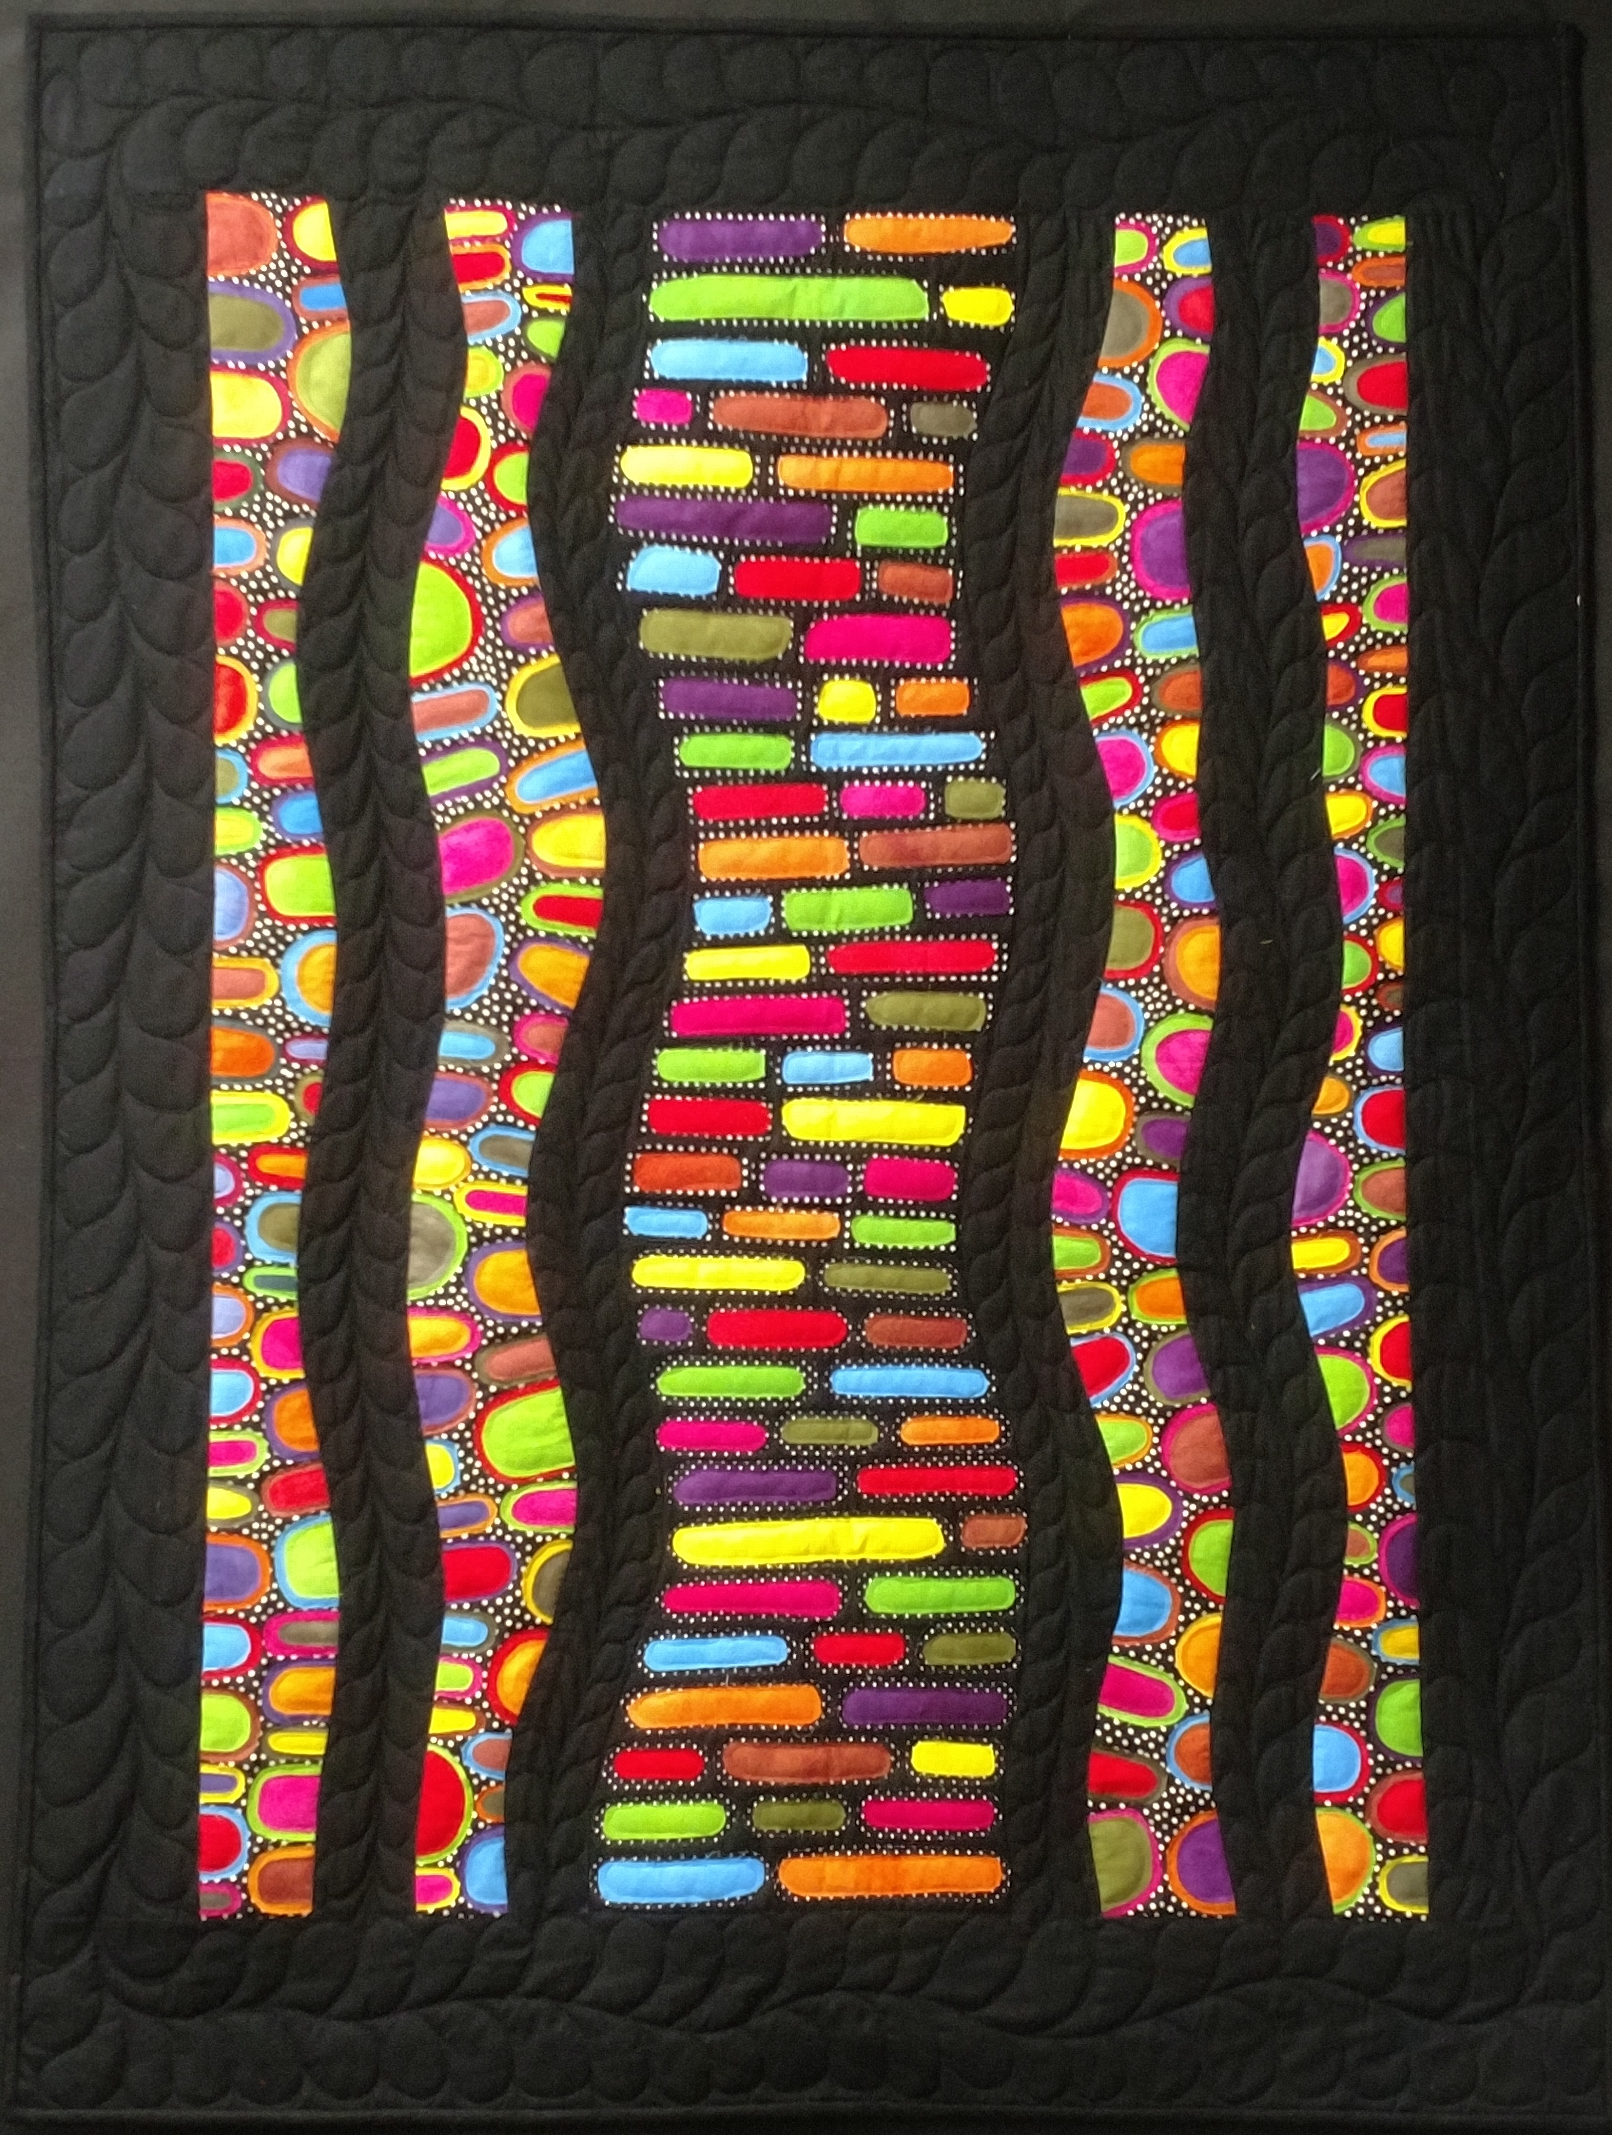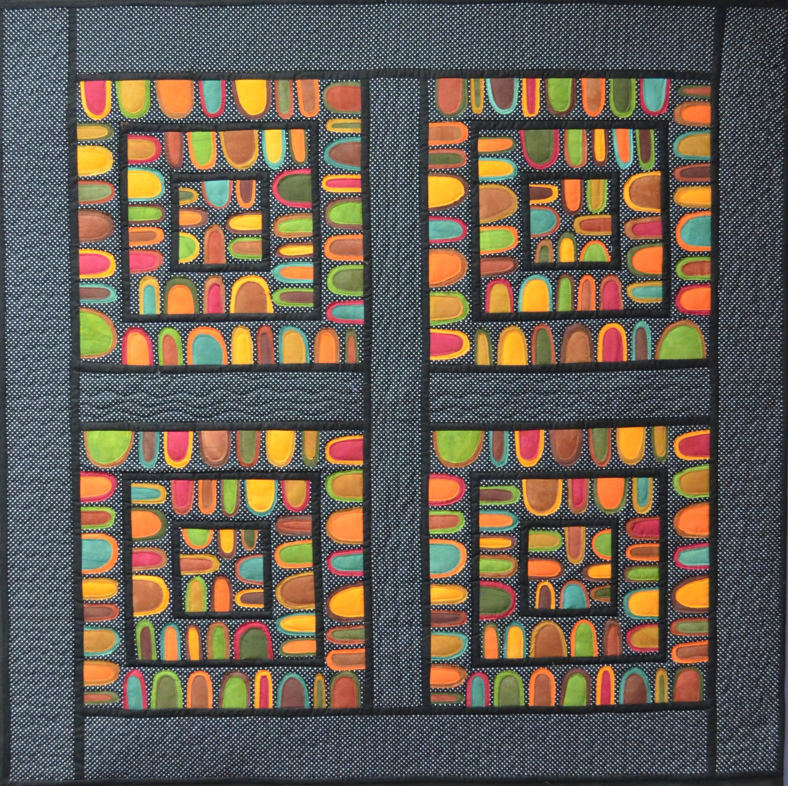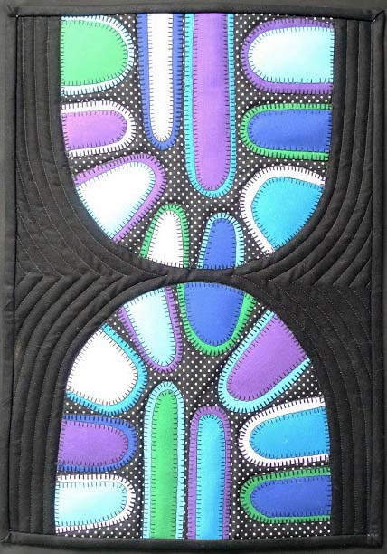
Moonlight Cobblestones Neighborhood Hills
33” x 40” 38” x 50” 47” x 47” 13” x 19”

- Sewing machine in good working order with normal attachments, including a quilting foot (The only stitching is done when we quilt and we may not get that far – but I like you to be prepared)
- Extension cord and/or power strip (unless these are provided for us)
- Iron and ironing boards (unless these are provided for us)
- Rotary cutter, mat, rulers
- Scissors, both paper and fabric
- Highlighters
- Thread – Colors to match each fabric - for quilting only – we may not get that far in class
- Pattern - Pick any of the 4 patterns. I will bring these with me (or you can buy on-line at www.ilenebartos.com but shipping will apply) Moonlight Pattern - 34.00; Cobblestones Pattern - 35.00; Neighborhood Pattern – 15.00; Hills Pattern – 15.00
- Kits that INCLUDE the pattern will also be available at class. Moonlight Kit – 95.00; Cobblestones Kit – 80.00; Neighborhood Kit – 80.00; Hills Kit – 30.00
- You are also free to bring your own fabrics as listed below.
- 3-4 yards of paper backed fusible - my favorite is Flexi-Fuse or Soft Fuse
- Fusible Stabilizer – Pellon Featherweight Fusible
- Marking tools – pencil and permanent marker (no ink)
- Optional - Light Box
- Large baggies for organizing fabrics
- Optional - Large Wool Pressing Mat
- Batting

Fabrics if you are bringing your own:
Moonlight: 25 colors for background and sections in various sizes; colors range from whites to dark browns, grays from light to dark, Greens, Oranges, Reds. 1 1/3-yard backing.
Cobblestones: 7/8 yard of black with white dots; 2 1/8 yards of solid black, Fat Eighth of nine primary colors, 1 1/3-yard backing.
Neighborhood: 2 1/3 yard black with white dots, 1 1/3 yard solid black; 1 Fat Quarter in each of 10 fall colors of greens, golds, rusts, browns, 3 yards backing.
Hills: 1 Fat Quarter of black with white dots, 2/3 yard of solid black, 3½” strip each of 6 colors, blues, greens, purples and 1 fat quarter for backing.

